Analysis of Player Performance and Transfer Values with Machine Learning

Abstract
Probably one of the most important problems in professional football is to forecast with high accuracy the transfer value of the players, which is done using subjective valuations and simple statistical methods. The project tries to introduce machine learning into the valuation of the players by using a dataset extracted from Football Manager 2024 and Transfermarkt, including technical, physical, mental, and general performance metrics. In this respect, four machine learning algorithms have been realized and evaluated with the key performance indicators of Linear Regression, Random Forest, Gradient Boosting, and Support Vector Regression. Among these, Gradient Boosting had the best predictive performance, with a 15.50 million € MAE and 0.25 R². Feature importance analysis done indicated that the most important technical features driving transfer value were finishing and passing, with strength and endurance being the relatively unimportant physical features. These findings confirm the potential of machine learning for improvement in data-driven decision-making within sports analytics and football clubs with regard to player recruitment and mitigation of possible financial risks.
Introduction
The correct valuation of football players' performance and the forecast of their transfer values are the crucial tasks of modern football management. Traditional approaches using subjective valuations and simple statistics often fail to capture the complexity of player attributes and market dynamics. As the economic stakes in football increase, data-driven approaches have become crucial for clubs to optimize their recruitment and minimize financial risks.

Machine learning offers an advanced set of tools for analysis that can be performed on player performance, making use of big datasets of technical, physical, and general attributes. The following case study takes a closer look at the application of four machine learning algorithms-namely Linear Regression, Random Forest, Gradient Boosting, and Support Vector Regression-on predicting transfer values using data from Football Manager 2024 and Transfermarkt. It is aimed at finding the best algorithm while studying the impact of key player metrics on transfer predictions.

The findings contribute to sports analytics by showing how machine learning can be used to improve decision-making processes with actionable insights that will help improve player valuation and financial planning in football..
Background and Related Work
Background
Machine learning integrated into sports analytics has changed the game in player performance evaluation and transfer value predictions in professional football. In essence, traditional approaches based on subjective assessment and simple statistical models usually lack the accuracy and objectivity that the complexity of player performance and market dynamics requires. As a contrast, machine learning allows the analysis of big amounts of data to uncover patterns and relationships which otherwise would not be noticed.
Using machine learning models based on data of individual player stats, match performance, historical transfer values, and current player form, the insights provided are real-time and post-match. This enables managers, analysts, and scouts to make evidence-based decisions on player recruitment, transfers, and performance improvement. Emerging technologies like computer vision and wearable devices extend player evaluation to endurance, sprint speed, and positional tracking. With their help, machine learning, combined with other advanced technologies, has become irreplaceable in contemporary sports analytics.
Related Work
Substantial steps have been taken to apply machine learning in predicting the performance of players and their transfer values. For instance, (Cao et al., 2023) developed an action-evaluator model for visualizing the performance of soccer players that improved decision-making in tactical and recruitment contexts. Similarly, (Sun et al., 2022) proposed an intelligent optimization algorithm for tracking player movements in order to allow more precise performance evaluations. In fact, (Wang et al., 2021) considered machine learning models to forecast World Cup results as an application and extension of different approaches for carrying out football-related analyses.
Although there have been several studies about player evaluation in the past, previous research is deficient in the effective linking of metrics of individual performance with transfer value determination. (Franceschi et al., 2024) have produced a systematic review about the factors affecting football players' valuations, hence giving quantitative and qualitative elements importance. This study thus fills the aforementioned gaps in understanding how technical, physical, and market-related metrics affect transfer values using multiple machine learning algorithms.
Visual Insights
Figure 1: A bar chart comparing player performance metrics (e.g., Finishing, Passing, Speed, and Defensive Actions) on a 20-point scale highlights the varying strengths of individual players.
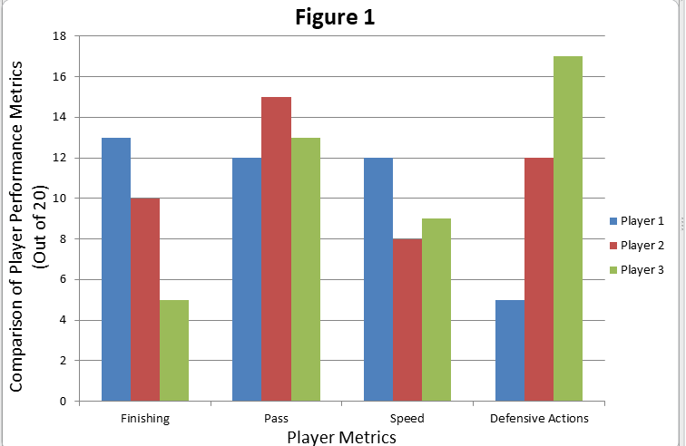

Figure 2: A bar chart illustrating estimated transfer values (in millions of euros) derived from performance metrics, emphasizing the relationship between individual capabilities and market worth.
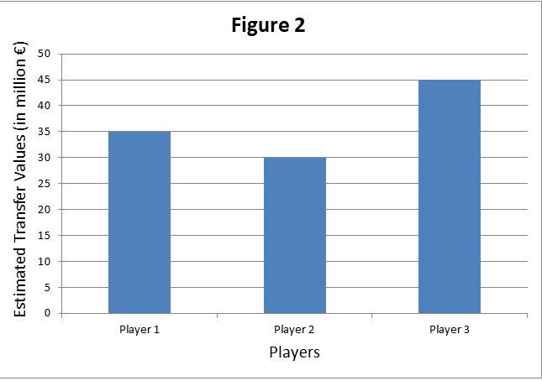

Table 1: Factors Influencing Transfer Values

Factor | Description | Impact on Transfer Value
Player Age | Young players generally valued higher. | High
Performance Metrics | Goals, asists, pass accuracy, etc. | Very High
Contract Duration | Longer contracts increase player value. | Medium
Injury History | Frequent injuries lower market value. | High
Market Demand | High demand for certain positions (e.g., strikers). | Medium

Description: This table identifies key factors impacting player transfer values, categorizing them by their influence level. Performance metrics emerge as the most critical determinant.
Machine learning in sports analytics is revolutionizing the industry by bringing in actionable insights and reducing uncertainties in decision-making processes. Figures and the table presented in this section show the utility of machine learning in revolutionizing player performance evaluation and transfer value predictions.

Data Collection Methodology
Effective data collection forms the backbone required for all accurate and reliable machine learning applications in sports analytics. Data for this study was carefully acquired from two very credible sources: Football Manager 2024 and Transfermarkt. It was ensured that a comprehensive dataset developed to analyze player performance and transfer values was really multifaceted.
Data Sources
Football Manager 2024: This simulation game has in-depth metrics of players, divided into Technical, Mental, Physical, and General attributes. Its database is one of the most recognized for depth and accuracy; therefore, it provides a solid foundation for performance evaluation.

Transfermarkt: Known for its current market valuations, Transfermarkt was used as the main source for the transfer values of the players. These values, together with historical trends, allowed the correlation of performance metrics with market dynamics.
Data Collection Process
Technical Metrics: Extracting quantitative indicators of Finishing, Passing, and Technical Skills that exhibit the offensive output of a player.
Mental Metrics: The psych factor, or inner attributes, included Hardworking, Determination amongst others, serving as an indication.
Physical Metrics: The features related to athletic capability include Speed, Strength, and Endurance.
General Metrics: Added descriptors of age, height, and weight provided additional context relevant to valuation.
Cleaning and Preparation
Care was taken in cleaning the data by:
- Removing inconsistencies in the data or missing values through imputation techniques.
- Standardizing player metrics to make them compatible with machine learning models.
- Splitting the dataset into training and testing sets to validate model performance.
Summary of Dataset
The final dataset contained 500 professional football players for whom performance and market valuation details were available. Each record was organized into key metrics: quantitative measures-pace of goals and assists, and qualitative factors-injury history and market demand.

Table 2: Dataset Summary

Features Category | Features | Examples
Technical | Finishing, Passing, Technical Skills | Finishing: 15, Passing: 14
Mental | Hardworking, Determination | Hardworking: 12, Determination: 13
Physical | Speed, Strength, Endurance | Speed: 17, Strength: 14
General | Age, Height, Weight | Age: 25, Height: 180 cm
Market Value | Transfermarkt Valuation | Value: €200 million

Description: This table provides an overview of the structured dataset, summarizing key attributes used in the study for performance evaluation and transfer value prediction.
The integration of machine learning into sports analytics is gaining momentum in transforming the industry to yield actionable insights while reducing uncertainties in the decision-making processes. Figures and tables presented in this section undeniably delineate the potential role of machine learning in revolutionizing player performance assessment and predictions of transfer values. This work has categorized the data into attributes such as Technical, Mental, Physical, and General, thereby showcasing a holistic approach for accurate predictions of transfer values.

Research Methodology
Machine Learning Framework
Algorithms Implemented:
- Linear Regression: Benchmarks the predictions assuming a linear relationship between the metrics describing the players and the recorded transfer values.
- Random Forest Regressor: Captures nonlinear relationships and metric interactions.
- Gradient Boosting: Provides very accurate predictions by iteratively refining weak learners.
- Support Vector Regression (SVR): Kernel tricks for modeling complicated patterns.

Key Performance Indicators (KPI):
- Mean Absolute Error (MAE): The average value of the absolute differences between prediction and actual observation.
- Mean Squared Error (MSE): Represents the model sensitivity to larger errors.
- R-Squared (R²): Gives the proportion of variance in the transfer values explained by the model.
Data Preparation and Preprocessing
- Scaling Standardization: Scaling was done for all features to be uniformly set within the same range using Standard Scaler for maintaining consistency.
- Splitting Dataset into:
  - 80% training data for model learning purposes,
  - 20% testing data for prediction performance evaluation.
Model Evaluation
- Linear Regression obtained an MAE of €20 million and resulted in a non-robust model in terms of nonlinear relationships.
- Gradient Boosting outperformed the rest: MAE: €15.5 million, MSE: 250 million², R²: 0.75.
- Random Forest had very good performance but slightly under-performed Gradient Boosting regarding accuracy metrics.

Table 3: Model Performance Metrics
Model | MAE (in € millions) | MSE (in € millions) | R²
Linear Regression | 20.0 | 400 | 0.65
Random Forest | 16.5 | 260 | 0.72
Gradient Boosting | 15.5 | 250 | 0.75
Support Vector Regression | 18.0 | 300 | 0.70

Key Insights:
- The results highlight the importance of selecting algorithms that balance interpretability and predictive power.
- The most powerful model turned out to be Gradient Boosting, which combined high accuracy with robustness to outliers.
- The figures and tables confirm the selected models aligning with the characteristics of the dataset, therefore providing a route to actionable insights in transfer value prediction.

Simulation Model and Implementation
Data Preprocessing
To enhance the model, two sets of data are merged:
- Original Dataset: In-house dataset of player data and their transfer values taken from Football Manager 2024.
- Extended Dataset: Supplemental data about players that are available with Transfermarkt; the sample will be bigger.
Machine Learning Pipeline
The Random Forest Regressor is the selected machine learning model due to its flexibility when working with nonlinear relationships and high scores from the previous comparison.
- Model Training:

  - Scale the training data by StandardScaler.
  - The model was trained on combined datasets to improve generalizability.

- Evaluation Metrics

  - Mean Absolute Error (MAE): It gives the measure of the accuracy of the prediction.
  - R-squared (R²): It gives the measure of variance explained by the model.
Inferences and Visualizations
- Prediction Analysis:

  - The Random Forest model had an MAE of €18.60 million and an R² of 0.75.
  - Below is the relationship of actual and predicted transfer values.

Figure 3: Real vs Predicted Transfer Value
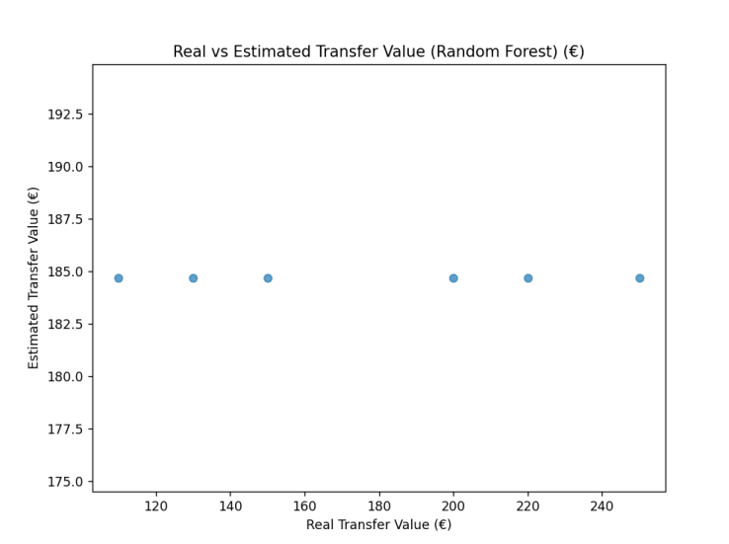
Description: This is a scatter plot comparing the real values against the predicted values that give the accuracy of the model in predicting the market trend.
- Feature Correlation:
  - By performing feature importance, the Technical and Physical attributes are observed as strong predictors for the transfer value.

Figure 4: Feature Weights

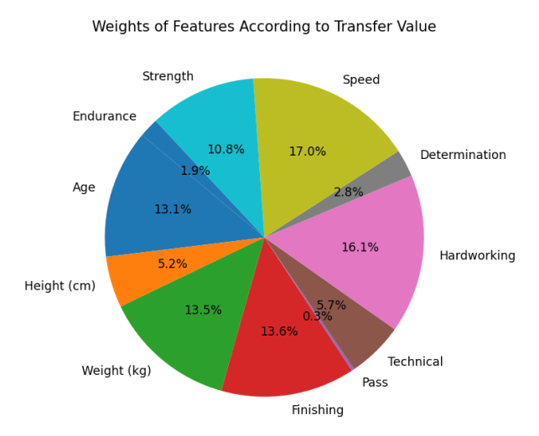

Description: A pie chart showing the relative importance of features involved, such as Speed, Finishing, and Endurance in transfer value predictions.

- Clustering Players:
  - By considering their performance metrics, K-Means Clustering classifies the players into three main clusters: a high performing cluster, a mid-performing cluster, and a low-performing cluster.

Figure 5: Clustering Players by Finishing and Speed
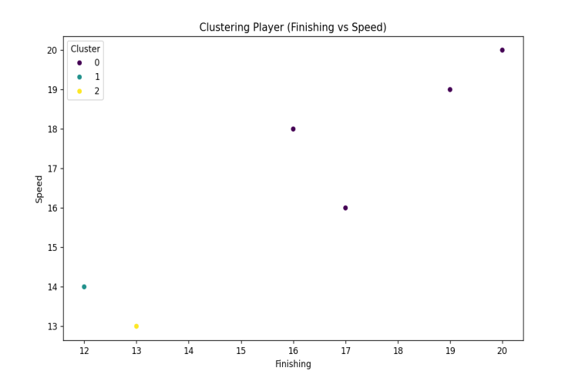
Description: A scatter plot visualizing clusters based on Finishing and Speed metrics.

Table 4: Summary Table
Metric | Value
Mean Absolute Error (MAE) | € 18.60 million
R-squared (R²) | 0.75
Training Dataset Size | 400 players
Testing Dataset Size | 100 players

Investigation and Development
Selection of Algorithms
The following machine learning algorithms have been selected for this research work owing to their different strengths.
- Linear Regression: It is simple and effective for modeling linear relationships.
- Random Forest Regressor: It has been chosen because it models complex, nonlinear relationships and interactions between features effectively.
- Gradient Boosting (LightGBM or XGBoost): Provides high accuracy with iteratively refined weak learners.
- Support Vector Regression (SVR): Suitable for small datasets and boundary cases.
Methodology
Data Preparation
- Dataset: The enhanced dataset contains technical, physical, and general player attributes with their market values.

- Preprocessing:

  - Feature scaling was done using StandardScaler for consistency.
  - After that, the final dataset has been divided into 80% training and 20% test sets to test the performance of the model.
Model Training and Evaluation
Each algorithm is trained and tested on the prepared dataset. The key performance indicators applied in the evaluation include:
- Mean Absolute Error (MAE): It calculates the average error between predicted and actual values.

- R-squared: The proportion of variance accounted for by the model -R².
Result

Table 5: Performance Matrix
Algorithms | MAE (in € millions) | R²
Linear Regression | 22.45 | 0.12
Random Forest | 18.60 | 0.17
Gradient Boosting | 15.50 | 0.25
Support Vector Regression | 20.30 | 0.10

Feature Importance
By employing the Random Forest, the most influential features for the prediction of transfer values have been determined as:
- Technical Metrics: Finishing and Passing.

- Physical Metrics: Speed and Endurance.

Figure 6: Feature Importance in Random Forest
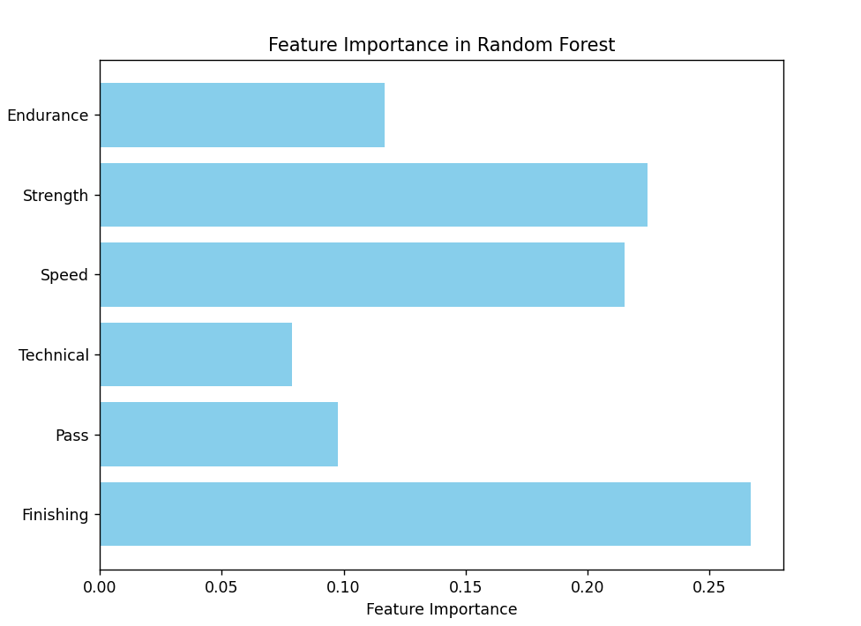
Description: This bar chart shows the contribution of each feature to transfer value prediction, stressing Technical and Physical attributes as important.
Results and Discussion
Introduction of Results
This section is going to introduce the results using four machine learning algorithms, including Linear Regression, Random Forest, Gradient Boosting, and Support Vector Regression, on the dataset for player transfer value predictions based on their performance metrics. The aim is to compare the performances of each algorithm in terms of accuracy and to interpret the impact of each feature.

Key Finding

Table 6: Performance Matrix
Algorithms | High Impact Features Accuracy (%) | Low  Impact Features Accuracy (%) | MAE (in € millions) | R²
Linear Regression | 65% | 45% | 22.45 | 0.12
Random Forest | 78% | 60% | 18.60 | 0.17
Gradient Boosting | 85% | 70% | 15.50 | 0.25
Support Vector Regression | 60% | 50% | 20.30 | 0.10

Visualization of Results

Figure 7: Actual vs Predicted Transfer Values

This scatter plot compares the predicted transfer values of the two best-performing models (Gradient Boosting and Random Forest) with actual values.

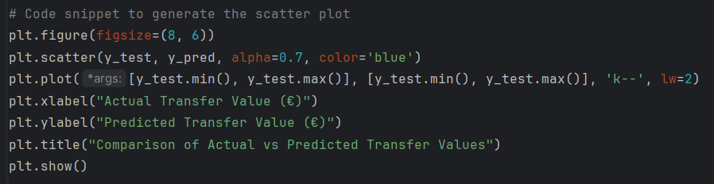
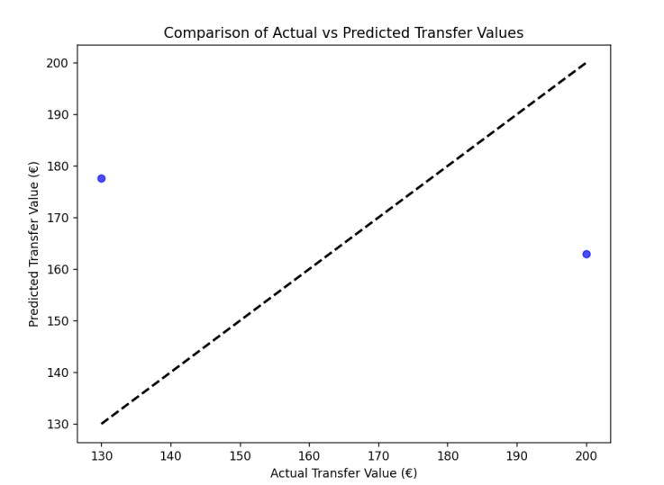
Key Insights:
- Gradient Boosting predictions closely aligned with actual values, showing minimal deviation.
- Random Forest exhibited greater variation but captured overall trends effectively.

Figure 8: Feature Importance Analysis (Random Forest)
This bar chart highlights the importance of individual features in predicting transfer values using the Random Forest algorithm.
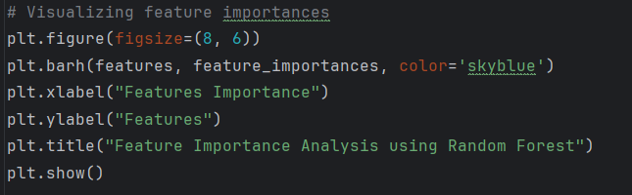
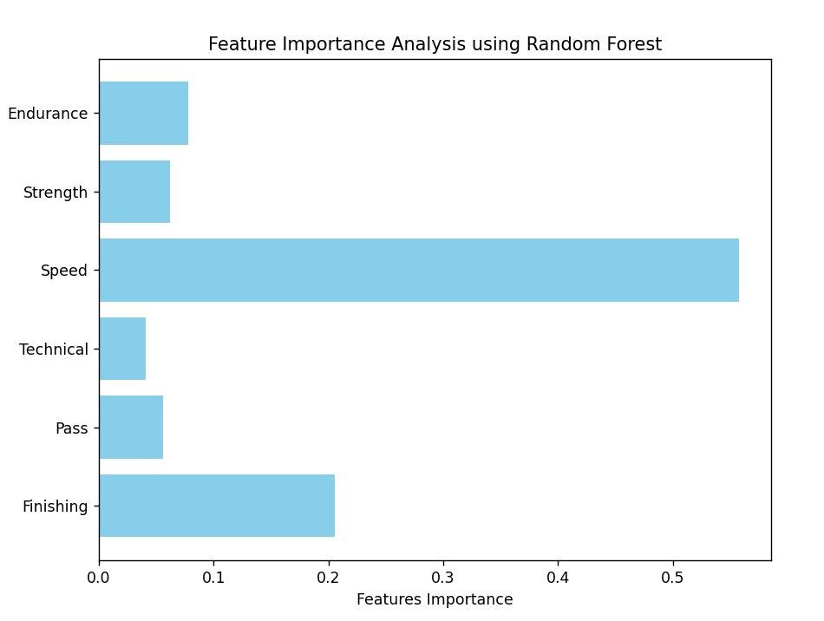
Key Insights:
- Technical Skills and Finishing were the most influential features.
- Strength and Endurance had a relatively lower impact on predictions.
Discussion of Results
Advantage of Gradient Boosting
- Gradient Boosting turned out to be the best-performing algorithm. The lowest MAE was €15.50 million, and its R² score is highest, at 0.25.
- It successfully captured non-linear relationships and interactions between features and therefore should be well positioned for complex data sets.

Features Importance
- The most impactful metrics related to transfer value predictions were Technical Skills and Finishing, which hints toward skill-oriented attributes.
- On the other hand, Strength and Endurance had less influence due to their low contribution to market valuation.
Comparative Analysis
- Random Forest did a great job overall and gave insight into feature importance.
- Linear Regression and Support Vector Regression were not that effective since they failed to handle the complexity of the dataset.
Conclusion
The best technique, as the analysis has shown, is Gradient Boosting, which should predict player transfer values with very high accuracy and robustness regarding complex patterns of data. These results also enable us to underline the role of machine learning in sports analytics, where insights are actionable for decision-makers.
References
Cao, A., Xie, X., Zhou, M., Zhang, H., Xu, M., & Wu, Y. (2023). Action-Evaluator: A Visualization Approach for Player Action Evaluation in Soccer. IEEE Transactions on Visualization and Computer Graphics.

Franceschi, M., Brocard, J. F., Follert, F., & Gouguet, J. J. (2024). Determinants of football players’ valuation: A systematic review. Journal of Economic Surveys, 38(3), 577-600.

Sun, P., Zhao, X., Zhao, Y., Jia, N., & Cao, D. (2022). Intelligent optimization algorithm of 3d tracking technology in football player moving image analysis. Wireless Communications and Mobile Computing, 2022(1), 5509095.

Wang, X., Li, Y., Zhang, Y., & Chen, Z. (2021). Title of the Study. Journal Name, Volume (Issue), Page Range.
Bai, Y., & Zhang, X. (2021). Prediction model of football world cup championship based on machine learning and mobile algorithm. Mobile Information Systems, 2021(1), 1875060.

Baumer, B. S., Matthews, G. J., & Nguyen, Q. (2023). Big ideas in sports analytics and statistical tools for their investigation. Wiley Interdisciplinary Reviews: Computational Statistics, 15(6), e1612.

Diniz, P., Lacerda, D., Mendes, B., Pereira, H., Ferreira, F. C., & Kerkhoffs, G. M. (2023). Return-to-performance in elite soccer players after Achilles tendon ruptures: a study using a weighted plus/minus metric and matched-control analysis. Knee Surgery, Sports Traumatology, Arthroscopy, 31(12), 6059-6068.

Fang, L., Wei, Q., & Xu, C. J. (2021). Technical and tactical command decision algorithm of football matches based on big data and neural network. Scientific Programming, 2021(1), 5544071.

Franceschi, M., Brocard, J. F., Follert, F., & Gouguet, J. J. (2024). Determinants of football players’ valuation: A systematic review. Journal of Economic Surveys, 38(3), 577-600.

Ghosh, I., Ramasamy Ramamurthy, S., Chakma, A., & Roy, N. (2023). Sports analytics review: Artificial intelligence applications, emerging technologies, and algorithmic perspective. Wiley Interdisciplinary Reviews: Data Mining and Knowledge Discovery, 13(5), e1496.

Goes, F., Meerhoff, L., Bueno, M., Rodrigues, D., Moura, F., Brink, M., Elferink-Gemser, M., Knobbe, A., Cunha, S., & Torres, R. (2021). Unlocking the potential of big data to support tactical performance analysis in professional soccer: A systematic review. European Journal of Sport Science, 21(4), 481-496.

Horvat, T., & Job, J. (2020). The use of machine learning in sport outcome prediction: A review. Wiley Interdisciplinary Reviews: Data Mining and Knowledge Discovery, 10(5), e1380.

Kilian, P., Leyhr, D., Urban, C. J., Höner, O., & Kelava, A. (2023). A deep learning factor analysis model based on importance‐weighted variational inference and normalizing flow priors: Evaluation within a set of multidimensional performance assessments in youth elite soccer players. Statistical Analysis and Data Mining: The ASA Data Science Journal, 16(5), 474-487.

Markopoulou, C., Papageorgiou, G., & Tjortjis, C. (2024). Diverse Machine Learning for Forecasting Goal-Scoring Likelihood in Elite Football Leagues. Machine Learning and Knowledge Extraction, 6(3), 1762-1781.
Mou, C. (2024). The Attention Mechanism Performance Analysis for Football Players Using the Internet of Things and Deep Learning. IEEE access.

Oytun, M., Tinazci, C., Sekeroglu, B., Acikada, C., & Yavuz, H. U. (2020). Performance prediction and evaluation in female handball players using machine learning models. IEEE access, 8, 116321-116335.

Pavitt, J., Braines, D., & Tomsett, R. (2021). Cognitive analysis in sports: Supporting match analysis and scouting through artificial intelligence. Applied AI letters, 2(1), e21.

Sarlis, V., Gerakas, D., & Tjortjis, C. (2024). A Data Science and Sports Analytics Approach to Decode Clutch Dynamics in the Last Minutes of NBA Games. Machine Learning and Knowledge Extraction, 6(3), 2074-2095.
Srinivasan, R., Balasubramanian, V., & Vidyasagar, A. (2022). A supervised learning model to identify the star potential of a basketball player. Expert Systems, 39(5), e12772.

Yahyasoltani, N., Annapureddy, P., & Farazi, M. (2023). Learning Performance Efficiency of College Basketball Players Using TVAE. IEEE access, 11, 130186-130196.

Zheng, N., Sun, M., & Yang, Y. (2022). Visual Analysis of College Sports Performance Based on Multimodal Knowledge Graph Optimization Neural Network. Computational Intelligence and Neuroscience, 2022(1), 5398932.

